PIR Core: Implementation and Evaluation on a Real Video Catalog
Oct 13, 2026 · @Kartik

Summary
On a real video of 97 chunks (367 KB each, 35 MB in total), both private-retrieval backends returned every requested chunk correctly, and only the two-server XOR scheme kept up with playback on a 10 Mbit/s link.
- Correctness. Every batch of 1, 4, 8 and 16 chunks, fetched privately by each scheme, matched the original bytes.
- Data volume decides. The XOR scheme moves 2.0 times the chunk size per chunk; the single-server LWE scheme moves about 8.1 times (1504 KB up and 1468 KB down for a 367 KB chunk).
- Keeping up with playback. At 50 Mbit/s both schemes fetch a batch faster than it plays. At 10 Mbit/s a single LWE chunk needs about 2.6 s against its 2 s of video, while XOR needs about 0.6 s.
- Compute. One XOR batch took 10 to 134 ms of compute for 1 to 16 chunks; one LWE batch took 158 to 2707 ms. Timings differed by up to about 50% between two runs of the same setting.

Scope and role
This section covers the PIR core of the project: the two retrieval backends owned by Member A (PIR Core and Crypto Lead, Kartik) in the implementation plan. It reports what was measured when both backends served a real video catalog.
Streaming and buffering logic, server sharding and seek handling, network simulation, and the traffic-analysis attacker belong to the other members and are not evaluated here. Every number below comes from the author's own runs of run_catalog.py on a Windows machine; nothing is taken from other benchmarks or from the literature.

System design
Both backends sit behind one interface: setup(records) loads the chunks and retrieve(indices) privately returns the requested ones, so the streaming layer can swap one backend for the other without changes. A split client/server form of each backend passes plain arrays, so the networking layer can send them as they are.
 | Two-server XOR (information-theoretic) | Single-server LWE (computational)
Privacy holds if | the two servers do not collude | the LWE problem is hard for the one server
Query | one random bit per catalog chunk to each server; the second copy differs from the first only at the wanted chunk | for each matrix column wanted, a vector of 32-bit numbers that hides which column
Server work | XOR of the chunks the query selects | multiply the database matrix by the query
Answer | one chunk-sized XOR per server | 32-bit numbers: four bytes per database byte
One-time setup | none | the server computes a hint, the client downloads it
The LWE backend follows the SimplePIR design. It uses modulus 2^32, plaintext modulus 2^8 (one database byte per entry), dimension 1024, noise standard deviation 6.4 and a ternary secret. The catalog is stored as a byte matrix with a chunk in one or more columns. A chunk longer than a column spans several columns, and the client sends one query per column.
Both servers use the optimised scan in these runs: the XOR scan works block by block so each block is processed for every query in the batch while it is in cache, and the LWE multiplication uses exact floating-point matrix products on 16-bit halves of the query.

Experimental setup
One video was cut into segments with ffmpeg (MPEG-TS), giving 97 chunks. run_catalog.py pads every chunk to the same size, 367 KB (375,808 bytes), so the catalog is 97 chunks and 35 MB, and loads it into the chosen backend. It then fetches random batches of 1, 4, 8 and 16 chunks, checks each result byte for byte against the original, and prints the cost.
Four runs were made, each with one batch of every size:
- two-server XOR, with the link modelled at 50 Mbit/s
- single-server LWE, 50 Mbit/s
- two-server XOR, 10 Mbit/s
- single-server LWE, 10 Mbit/s
How each quantity was obtained:
- Compute is measured: client query building, server work and client decoding. Client and servers ran on one Windows machine (Git Bash), and the two XOR servers were simulated in one process.
- Data volume is measured: bytes uploaded and downloaded per batch.
- Transfer time is modelled, not measured: bytes sent and received, divided by the stated link speed, with no overlap between compute and transfer.
- Playback deadline: the script assumes each chunk holds 2 s of video (its default), so a batch of k chunks must be fetched in less than 2k seconds.
For the LWE run the catalog is a matrix of 5966 rows by 6111 columns, so each 367 KB chunk spans 63 columns and costs 63 column queries. These layout figures are derived from the catalog size, not printed by the script, and they reproduce the measured 1504 KB upload and 1468 KB download for one chunk. The one-time LWE setup, including the hint computation, took 1.6 s and 1.7 s in the two runs. The hint the client downloads once is about 23 MB by the same derivation.

Results
Compute is small next to the modelled transfer time at 50 Mbit/s: an XOR chunk costs about 8 to 10 ms of compute and an LWE chunk about 100 to 170 ms.
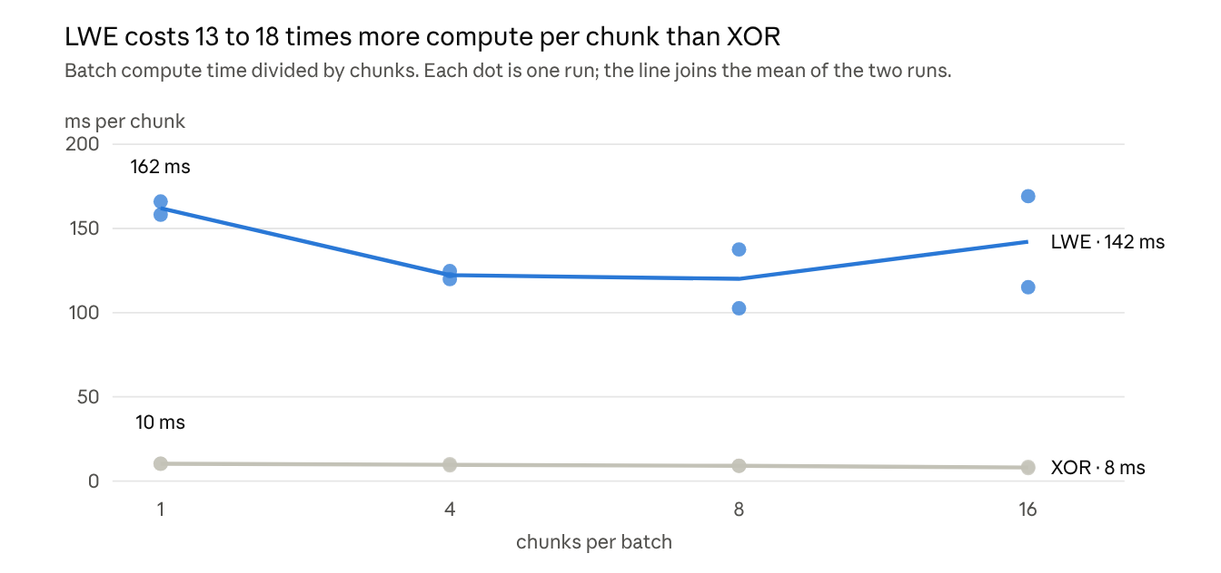
Author's runs of run_catalog.py, 97 chunks of 367 KB, Windows machine; two runs per scheme
Batching cut XOR compute per chunk by about 20 percent, from 10 ms at one chunk to 8 ms at sixteen. For LWE the two runs disagree: at sixteen chunks one run was above and one below the single-chunk cost, so no saving can be claimed.
Data moved per batch, measured (KB):
Chunks per batch | XOR download | LWE upload | LWE download
1 | 734 | 1504 | 1468
4 | 2936 | 6016 | 5873
8 | 5872 | 12031 | 11746
16 | 11744 | 24062 | 23491
XOR upload was too small to register (the script prints 0 KB): it is one bit per catalog chunk to each server. Per chunk, XOR moves 2.0 times the chunk size and LWE about 8.1 times.

Playback feasibility
At 50 Mbit/s both schemes fetch a chunk well inside the 2 s of video it holds; at 10 Mbit/s only XOR does.
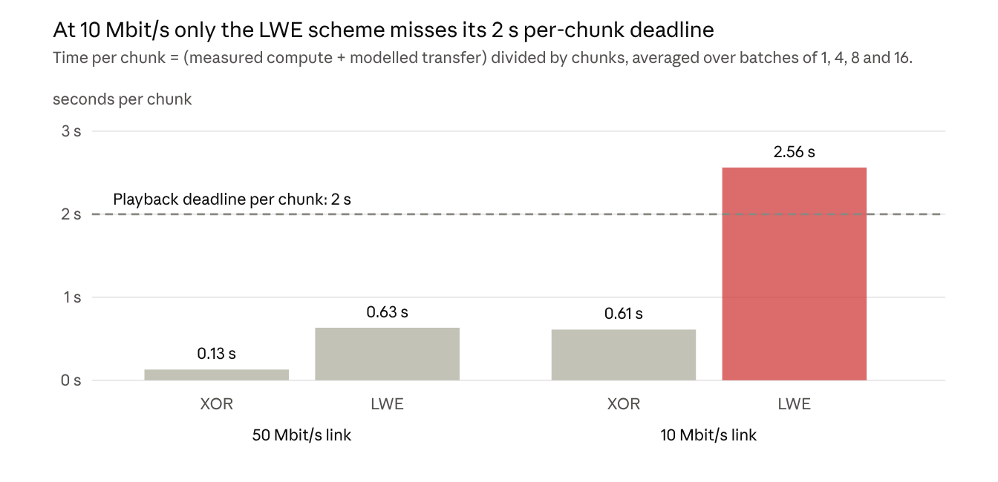
Author's runs of run_catalog.py; compute measured, transfer modelled from bytes and link speed, no compute/transfer overlap; chunk assumed to hold 2 s of video
Time per chunk barely changes with batch size: within each bar, the four batch sizes differ by at most 8 percent. Batching therefore does not rescue LWE at 10 Mbit/s.
Setting the per-chunk time equal to the 2 s deadline gives break-even link speeds of about 3 Mbit/s for XOR and about 13 Mbit/s for LWE, against a video bitrate of about 1.5 Mbit/s (367 KB per 2 s). These break-even figures are derived from the measured data volume and compute, not measured on a network.

Discussion
On this catalog the network, not the server, is what limits private streaming, and the cost of dropping the two-server assumption is mostly extra data.
- Transfer outweighs compute. At the modelled 50 Mbit/s, a single XOR chunk spends 120.3 ms on transfer against 10.3 ms of compute, and a single LWE chunk 486.9 ms against 158.2 ms.
- The price of one server. Compared with XOR, LWE needs about four times the data per chunk (8.1 times the chunk size against 2.0) and 13 to 18 times the compute. In return it needs no second server and no non-collusion assumption.
- Chunk length drives LWE cost. A 367 KB chunk is far longer than one matrix column (5966 bytes), so it spans 63 columns, and query and answer size grow with the number of columns. Shorter or lower-bitrate segments should therefore make LWE cheaper per chunk. This was not tested here.
- Setup. LWE needs a one-time setup of 1.6 s and a hint of about 23 MB for the client to download, which must be redone if the catalog changes. XOR needs neither.
For the streaming layer, these runs favour two-server XOR whenever two non-colluding servers are available, and single-server LWE only when one server is required and the viewer's link is above roughly 13 Mbit/s.

Limitations
The results come from one small catalog and one run per setting, so they show orders of magnitude rather than precise figures.
- Small catalog. One video, 97 chunks, 35 MB. A request hides which of only 97 chunks was wanted, and server time may change on a larger catalog; this was not tested.
- Noisy timings. Each batch size was run once per setting. The same LWE batch of 16 took 2707 ms in one run and 1842 ms in the other, so compute figures are good to roughly plus or minus 50 percent. The machine's CPU and memory were not recorded.
- Modelled transfer. Transfer time is bytes divided by an assumed link speed, with no overlap between compute and transfer and no real network. The two XOR servers ran in one process, so real two-machine latency is not included.
- Assumed deadline. Each chunk is assumed to hold 2 s of video (the script's default); the feasibility results scale with the true segment length.
- Security of the LWE backend. It is the team's own SimplePIR-style implementation. Its parameters follow the SimplePIR paper but were not re-checked with a lattice estimator, and its secrets and noise come from a non-cryptographic random generator that a deployment would replace.
- What PIR hides. Both schemes hide which chunk is requested. They do not hide traffic patterns such as batch sizes and request timing, which are outside this evaluation.

Conclusion and how to reproduce
Both PIR backends privately served a real 35 MB video catalog with correct results; the two-server XOR scheme kept up with playback at 10 Mbit/s and 50 Mbit/s, while the single-server LWE scheme kept up only at 50 Mbit/s because it moves about four times as much data.
To repeat the runs, from the pir_core folder:
- Install the libraries with pip install numpy, and install ffmpeg.
- Cut the video into segments, for example into seg/video1, as .ts files.
- Run python run_catalog.py xor seg/video1 and python run_catalog.py lwe seg/video1.
- Repeat with the link speed set, for example BW_MBPS=10 python run_catalog.py lwe seg/video1. The script also reads TAU, the seconds of video per chunk.

Appendix: raw output of the four runs
Condensed from the terminal output: the "FAST ENOUGH" labels and the repeated assumption lines are omitted, and the "TOO SLOW" labels are kept. Compute and data volume are measured; transfer is modelled.
$ python run_catalog.py xor seg/video1 (50 Mbit/s)
Catalog: 97 chunks of 367 KB each = 35 MB
Setup took 0.0 s
batch of 1 chunks: compute 10.3 ms | transfer (estimated) 120.3 ms | upload 0 KB | download 734 KB
batch of 4 chunks: compute 37.1 ms | transfer (estimated) 481.1 ms | upload 0 KB | download 2936 KB
batch of 8 chunks: compute 72.9 ms | transfer (estimated) 962.1 ms | upload 0 KB | download 5872 KB
batch of 16 chunks: compute 122.6 ms | transfer (estimated) 1924.2 ms | upload 0 KB | download 11744 KB
$ python run_catalog.py lwe seg/video1 (50 Mbit/s)
Setup took 1.6 s
batch of 1 chunks: compute 158.2 ms | transfer (estimated) 486.9 ms | upload 1504 KB | download 1468 KB
batch of 4 chunks: compute 479.6 ms | transfer (estimated) 1947.8 ms | upload 6016 KB | download 5873 KB
batch of 8 chunks: compute 1100.3 ms | transfer (estimated) 3895.6 ms | upload 12031 KB | download 11746 KB
batch of 16 chunks: compute 2706.9 ms | transfer (estimated) 7791.1 ms | upload 24062 KB | download 23491 KB
$ BW_MBPS=10 python run_catalog.py xor seg/video1 (10 Mbit/s)
batch of 1 chunks: compute 10.2 ms | transfer (estimated) 601.3 ms | upload 0 KB | download 734 KB
batch of 4 chunks: compute 39.9 ms | transfer (estimated) 2405.3 ms | upload 0 KB | download 2936 KB
batch of 8 chunks: compute 71.2 ms | transfer (estimated) 4810.5 ms | upload 0 KB | download 5872 KB
batch of 16 chunks: compute 134.3 ms | transfer (estimated) 9621.0 ms | upload 0 KB | download 11744 KB
$ BW_MBPS=10 python run_catalog.py lwe seg/video1 (10 Mbit/s)
Setup took 1.7 s
batch of 1 chunks: compute 166.0 ms | transfer (estimated) 2434.7 ms | upload 1504 KB | download 1468 KB TOO SLOW
batch of 4 chunks: compute 498.7 ms | transfer (estimated) 9738.9 ms | upload 6016 KB | download 5873 KB TOO SLOW
batch of 8 chunks: compute 820.8 ms | transfer (estimated) 19477.8 ms | upload 12031 KB | download 11746 KB TOO SLOW
batch of 16 chunks: compute 1841.6 ms | transfer (estimated) 38955.6 ms | upload 24062 KB | download 23491 KB TOO SLOW

